Computer Graphics

Practical File

CONTENTS: -

|  |  |
| --- | --- |
| **Sno.** | **Name of Practicals** |
| 1. | 1. Write a program to implement Bresenham’s line drawing algorithm. 2. Write a program to implement DDA line drawing algorithm. |
| 2. | 1. Write a program to implement mid-point circle drawing algorithm. 2. Write a program to implement mid-point ellipse drawing algorithm. |
| 3. | Write a program to clip a line using Cohen and Sutherland line clipping algorithm. |
| 4. | Write a program to clip a polygon using Sutherland Hodgeman algorithm. |
| 5. | Write a program to fill a polygon using Scan line fill algorithm. |
| 6. | Write a program to apply various 2-D Transformations on a 2-D object (TRIANGLE). |
| 7. | Write a program to apply various 3D Transformations on a 3D object and then apply parallel and perspective projection on it. |
| 8. | Write a program to draw Hermite and Bezier curve. |

1. **(i) Write a program to implement Bresenham’s line drawing algorithm.**

## CODE:

#include<iostream> #include<graphics.h> #include<conio.h> using namespace std;

//Bresenham function to implement bresenham's algo for 0<m<1 void Bresenham(int xa, int ya, int xb, int yb)

{

//calculating the constants dx and dy int dx = abs (xa - xb), dy = abs (ya - yb);

//calculating the decision parameter int p = 2 * dy - dx;

int twoDy = 2 * dy, twoDyDx = 2*(dy - dx); int x, y, xEnd,x_mid,y_mid;

x_mid=getmaxx()/2; y_mid=getmaxy()/2;

//determinig which point to use as start which as end if(xa > xb)

{

x = xb; y = yb;

xEnd = xa;

}

else

{

x = xa; y = ya;

xEnd = xb;

}

putpixel (x, y, YELLOW); while (x < xEnd)

{

x++;

if(p < 0)

{

p += twoDy; //calculating p for next point

}

else

{

y++;

p += twoDyDx; //calculating p for next point

}

putpixel (x_mid+x,y_mid-y, YELLOW);

}

}

//main function int main()

{

int gdriver = DETECT , gmode,error; initgraph(&gdriver, &gmode, (char*)"");

int x1,y1,x2,y2,x_mid,y_mid;

//input for points of the line cout<<"\nEnter Co-ordinates (x1,y1) :"; cout<<"\nx1 : ";

cin>>x1; cout<<"y1 : "; cin>>y1;

cout<<"\nEnter Co-ordinates (x2,y2) :"; cout<<"\nx2 : ";

cin>>x2; cout<<"y2 : "; cin>>y2;

cout<<"\nLINE USING BRESENHAM Algorithm";

//Creating the quadrants of the graph x_mid=getmaxx()/2; y_mid=getmaxy()/2;

line(x_mid,0,x_mid,getmaxy()); line(0,y_mid,getmaxx(),y_mid);

//calling the bresenham_algo function Bresenham(x1,y1,x2,y2);

getch(); closegraph(); return 0;

}

**OUTPUTS:**

**I - Quadrant**

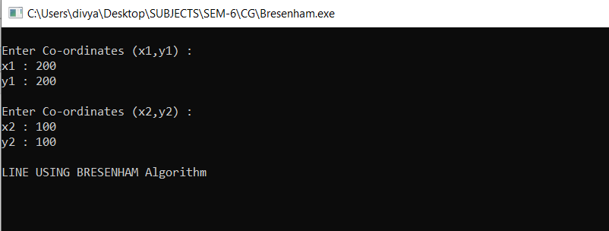

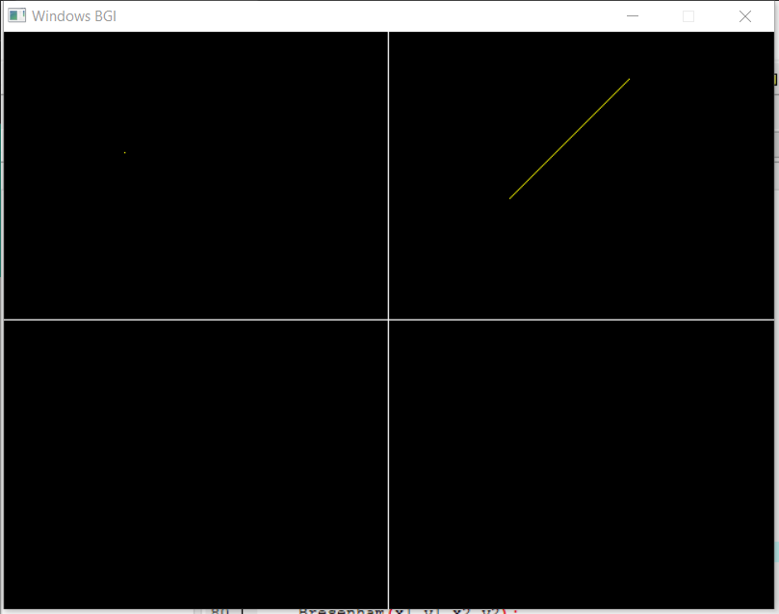

**III - Quadrant**

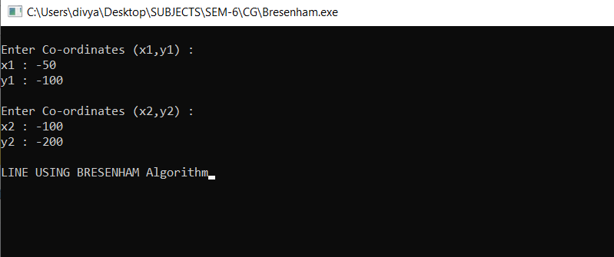

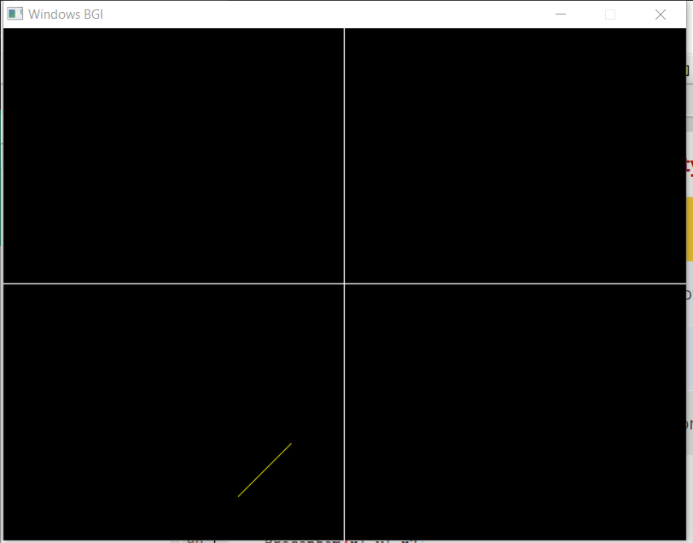

**(ii) Write a program to implement DDA line drawing algorithm.**

## CODE:

#include<iostream> #include<conio.h> #include<graphics.h> #include<math.h>

#define ROUND(a)((int)(a+0.5)) using namespace std;

// Variables for changing the origin float x_mid, y_mid;

//lineDAA function to implement DDA algorithm... int lineDDA(int xa, int ya, int xb, int yb)

{

//calculating dx and dy int dx = xb-xa;

int dy = yb-ya; int steps, k;

float xIncr, yIncr; float x = xa, y = ya;

// difference(dx,dy) with the greater magnitude determines the value of parameter steps if(abs(dx) > abs(dy))

{

}

else

{

}

steps = abs(dx);

steps=abs(dy);

xIncr = dx/(float) steps; yIncr = dy/(float) steps;

putpixel(ROUND(x) + x_mid, y_mid - ROUND(y), YELLOW);

//looping to generate next pixcel position step times for(k = 0; k < steps; k++)

{

x += xIncr; y += yIncr;

putpixel(ROUND(x) + x_mid, y_mid - ROUND(y), YELLOW);

}

return 0;

}

//main function int main()

{

int gd= DETECT, gmode; initgraph(&gd,&gmode, "");

//shifting the origin to the middle of screen float X = getmaxx(), Y = getmaxy();

x_mid = X/2; y_mid = Y/2;

int x1, y1, x2, y2;

cout<<"\nEnter Co-ordinates (x1,y1) :"; cout<<"\nx1 : ";

cin>>x1; cout<<"y1 : "; cin>>y1;

cout<<"\nEnter Co-ordinates (x2,y2) :"; cout<<"\nx2 : ";

cin>>x2; cout<<"y2 : "; cin>>y2;

cout<<"\nLINE USING DDA Algorithm";

line(x_mid, 0, x_mid, Y); line(0, y_mid, X, y_mid);

//calling the lineDAA fuction lineDDA(x1,y1,x2,y2);

getch(); closegraph(); return 0;

}

**OUTPUTS:**

1. **- Quadrant**

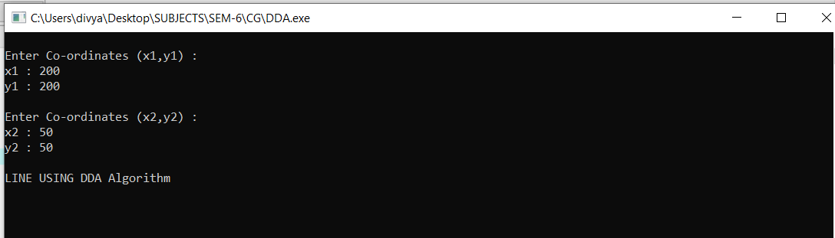

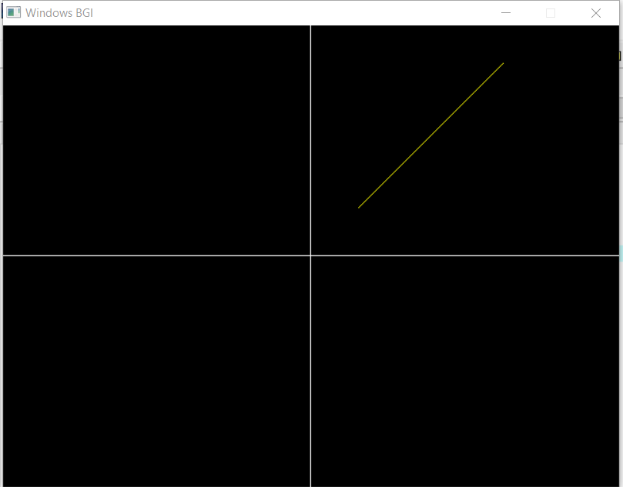

1. **- Quadrant**

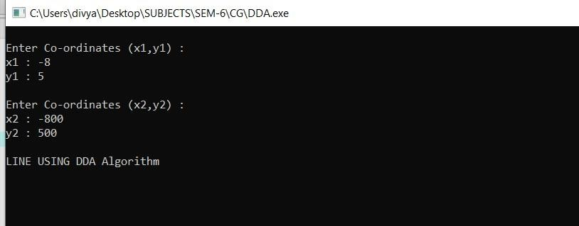

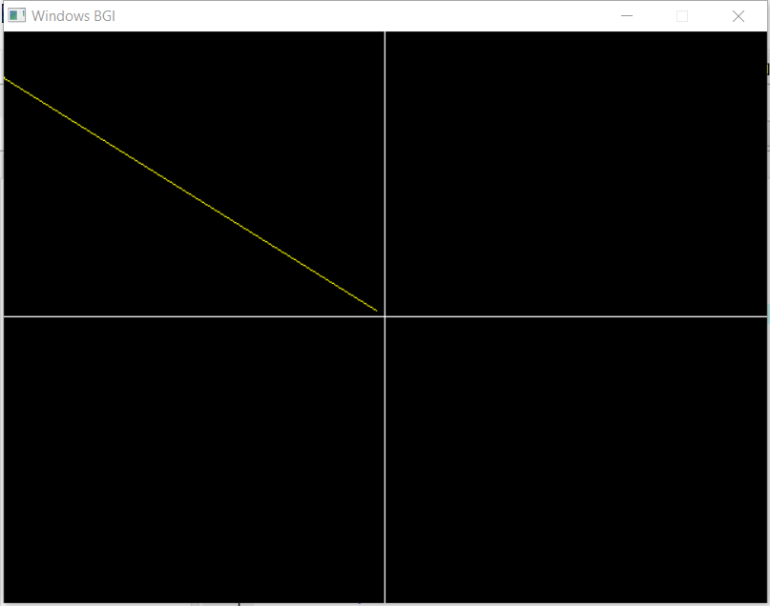

1. **- Quadrant**

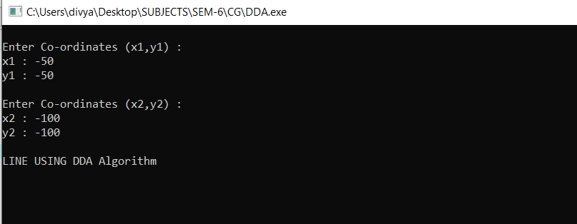

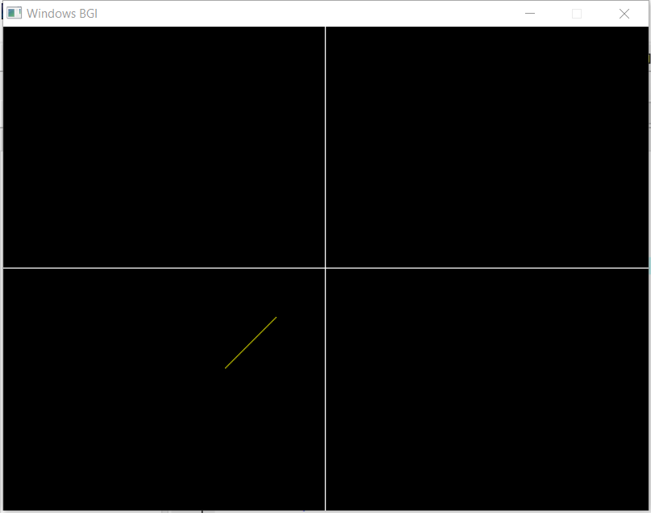

1. **- Quadrant**

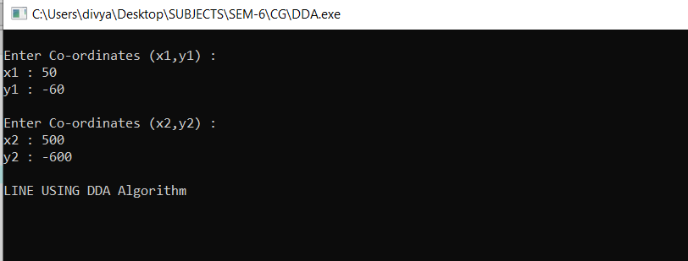

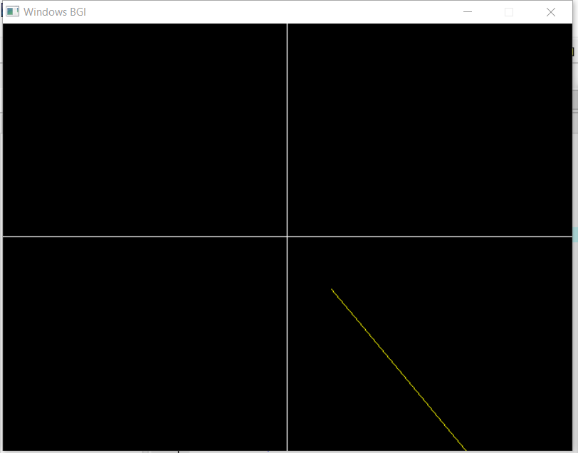

1. **(i) Write a program to implement mid-point circle drawing algorithm.**

## CODE:

#include<iostream> #include<graphics.h> #include<math.h>

using namespace std;

void circlePlotPoints (int, int, int, int); int x_mid,y_mid;

//Circle function to implement mid point circle's algorithm... void Circle(int xCenter, int yCenter, int radius)

{

int x = 0;

int y = radius;

int p = 1 - radius;

// calculating all the perimeter points of the circle in the first octant while (x <= y)

{

//plotting first set of points circlePlotPoints (x, y, xCenter, yCenter);

//if p lies inside or on the circle perimeter, we plot the pixel (x, y+1), otherwise if it’s outside

we plot the pixel (x-1, y+1)

if (p < 0)

{

p += (2*x)+1;

}

else

{

p +=(2*(x-y))+1; y--;

}

x++ ;

}

}

// displaying the calculated points in the first octant along with their mirror points in the other octants void circlePlotPoints(int x, int y, int xCenter, int yCenter)

{

putpixel (xCenter + x, yCenter + y, YELLOW); putpixel (xCenter - x, yCenter + y, YELLOW); putpixel (xCenter + x, yCenter - y, YELLOW); putpixel (xCenter - x, yCenter - y, YELLOW); putpixel (xCenter + y, yCenter + x, YELLOW); putpixel (xCenter - y, yCenter + x, YELLOW); putpixel (xCenter + y, yCenter - x, YELLOW);

putpixel (xCenter - y, yCenter - x, YELLOW);

}

//main function int main()

{

int x , y; float r;

int gd = DETECT , gm; initgraph(&gd, &gm, (char*)"");

//inputs for the circle cout<<"\nEnter Co-ordinates (x,y) :"; cout<<"\nx : ";

cin>>x; cout<<"y : "; cin>>y;

//radius of the circle cout<<"\n Enter the radius= "; cin>>r;

cout<<"\nDRAWING CIRCLE USING MID POINT CIRCLE Algorithm";

//Creating the quadrants of the graph x_mid = getmaxx()/2;

y_mid = getmaxy()/2;

line(x_mid , 0 , x_mid , getmaxy()); line(0 , y_mid , getmaxx() , y_mid);

//calling circle funtion

circle(x + x_mid , y_mid - y , r);

getch(); closegraph(); return 0;

}

**OUTPUTS:**

**Circle at origin: (0,0)**

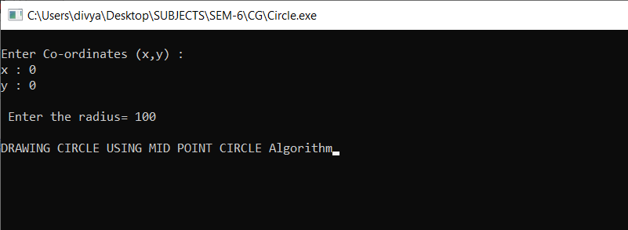

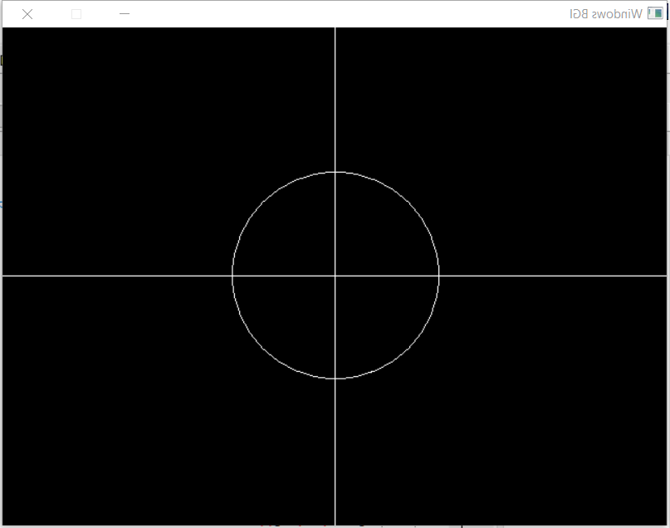

* 1. **- Quadrant**

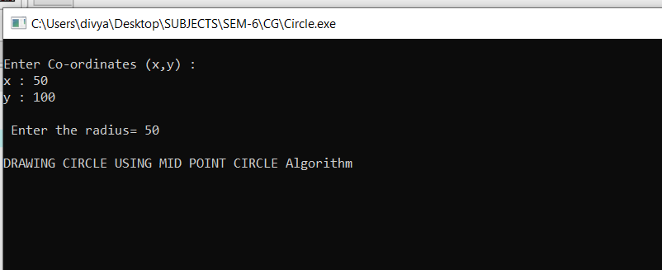

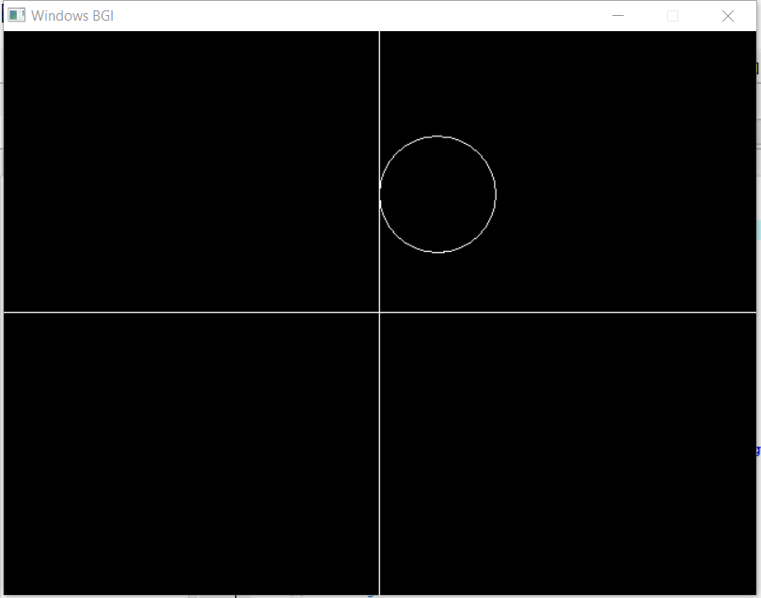

* 1. **- Quadrant**

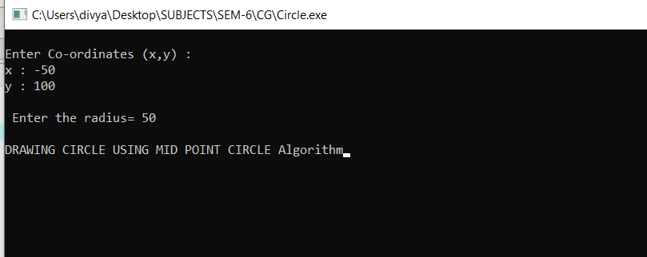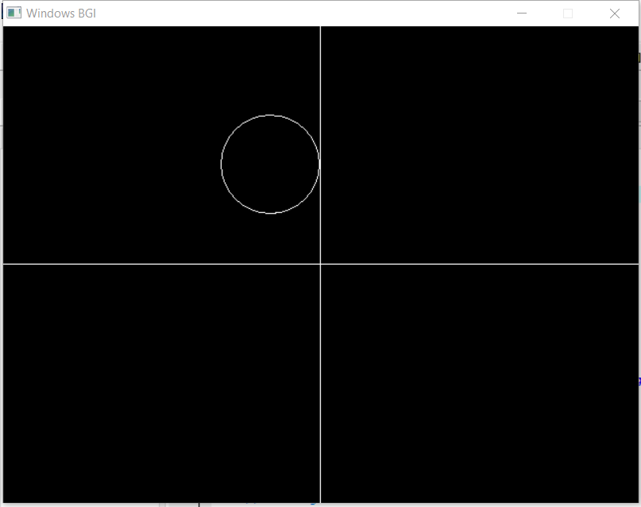

**III- Quadrant**

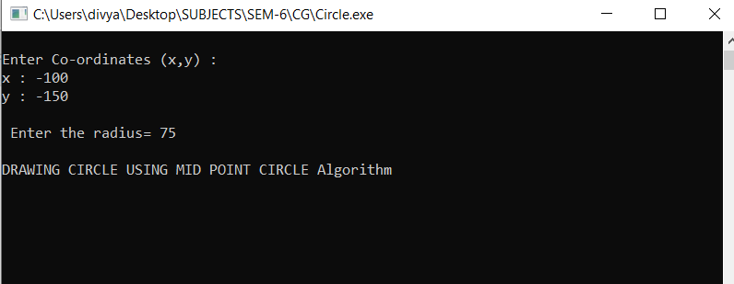

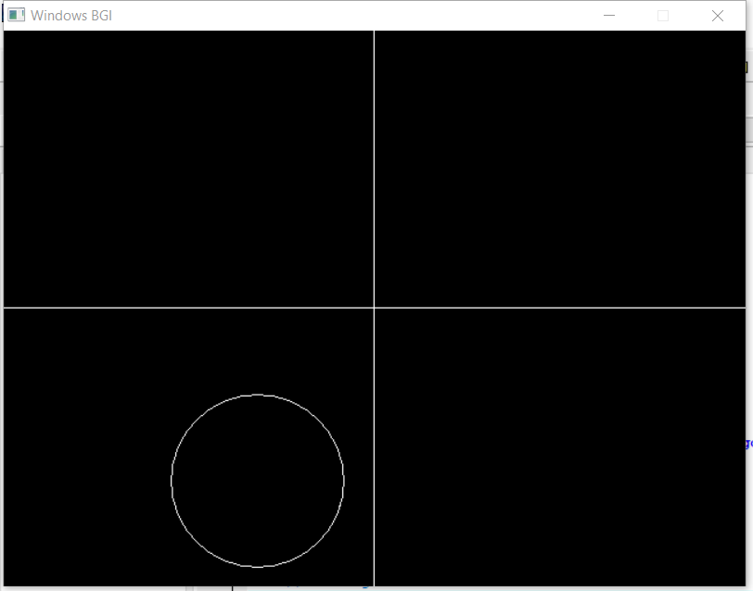

**IV - Quadrant**

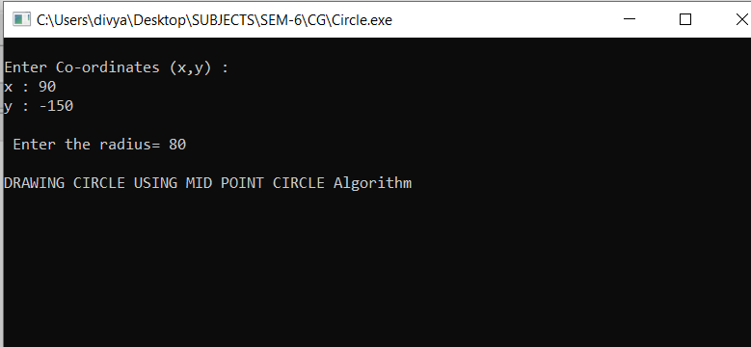

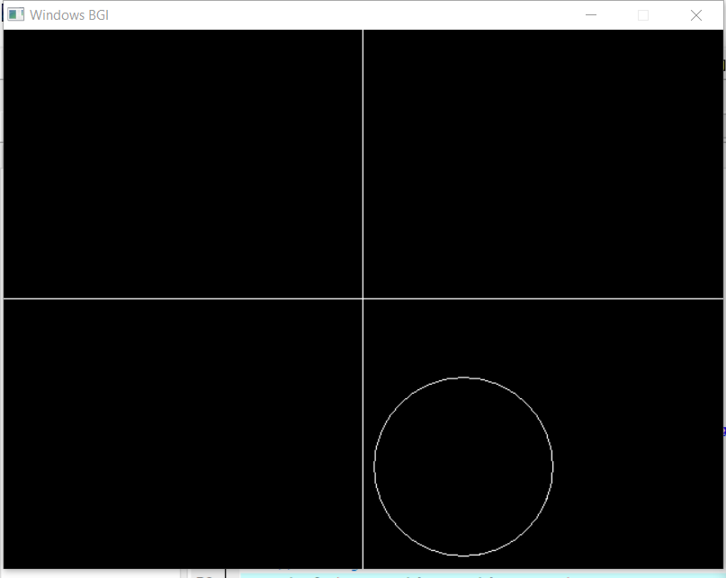

**(ii) Write a program to implement mid-point ellipse drawing algorithm.**

## CODE:

#include<iostream> #include<graphics.h> #include<math.h>

using namespace std;

#define ROUND(a) ((int) (a+0.5))

void ellipsePlotPoints(int, int, int, int); int x_mid ,y_mid;

//Ellipse function to implement mid point circle's algorithm... void Ellipse(int xCenter, int yCenter, int Rx, int Ry)

{

int Rx2 = Rx*Rx; int Ry2 = Ry*Ry;

int twoRx2 = 2*Rx2; int twoRy2 = 2*Ry2; int p;

int x = 0; int y = Ry; int px = 0;

int py = twoRx2 *y;

//plotting first set of points ellipsePlotPoints(xCenter, yCenter, x, y);

//Midpoint ellipse algorithm plots points of an ellipse on the first quadrant by dividing the quadrant into two regions

//region 1

p = ROUND(Ry2 - (Rx2 * Ry) + (0.25 * Rx2));

while (px < py)

{

x++;

px += twoRy2;

if (p < 0)

{

p += Ry2 + px;

}

else

{

y--;

py -= twoRx2;

p += Ry2 + px - py;

}

ellipsePlotPoints(xCenter, yCenter, x,y);

}

//Region 2

p = ROUND (Ry2*(x+0.5)*(x+0.5) + Rx2*(y-1)*(y-1) - Rx2*Ry2);

while (y > 0)

{

y--;

py -= twoRx2;

if (p > 0)

{

p += Rx2 - py;

}

else

{ x++;

px += twoRy2;

p += Rx2 - py + px;

}

ellipsePlotPoints(xCenter, yCenter, x, y);

}

}

//function to plot points of ellipse in symmentry

void ellipsePlotPoints (int xCenter, int yCenter, int x, int y)

{

putpixel (xCenter + x, yCenter + y, YELLOW); putpixel (xCenter- x, yCenter + y, YELLOW); putpixel (xCenter+ x, yCenter - y, YELLOW); putpixel (xCenter - x, yCenter - y, YELLOW);

}

//main function int main()

{

int x , y; float r,r2;

int gd = DETECT , gm; initgraph(&gd, &gm, (char*)"");

//inputs for the circle cout<<"\nEnter Co-ordinates (x,y) :"; cout<<"\nx : ";

cin>>x;

cout<<"y : "; cin>>y;

//radius of the circle

cout<<"\n Enter the radius 1= "; cin>>r;

cout<<"\n Enter the radius 2= "; cin>>r2;

cout<<"\nDRAWING ELLIPSE USING MID POINT ELLIPSE Algorithm";

//creating the quadrants of the graph at the center. x_mid = getmaxx()/2;

y_mid = getmaxy()/2;

line(x_mid , 0 , x_mid , getmaxy()); line(0 , y_mid , getmaxx() , y_mid);

//calling of Ellipse function... Ellipse(x + x_mid , y_mid - y , r,r2);

getch(); closegraph(); return 0;

}

**OUTPUTS:**

**Ellipse at origin : (0,0)**

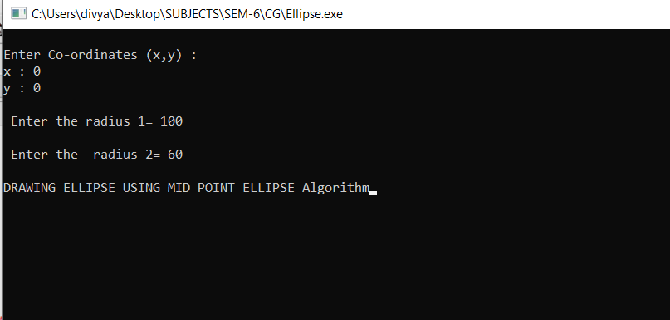

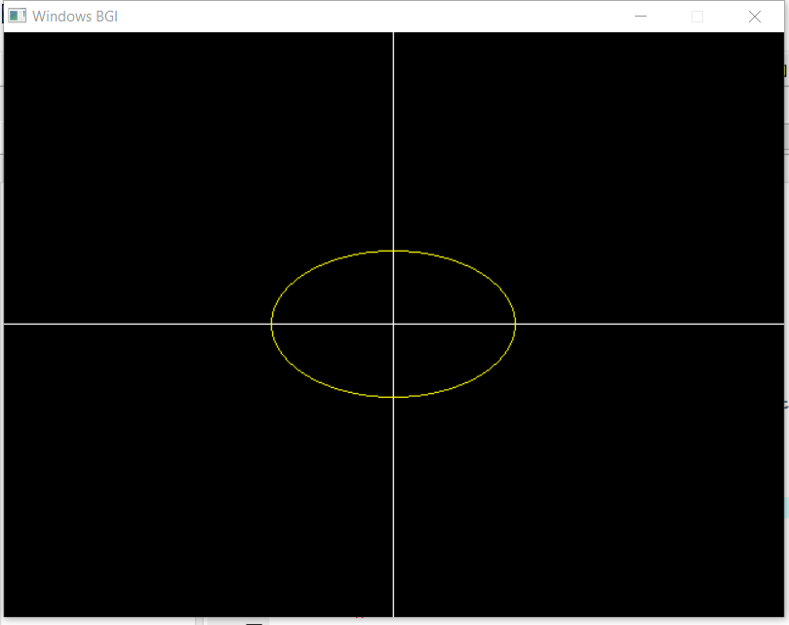

1. **– QUADRANT**

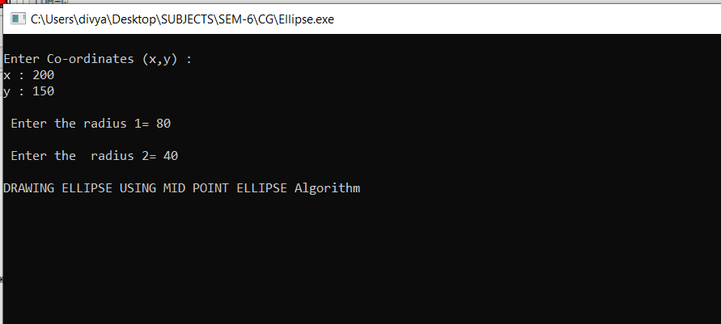

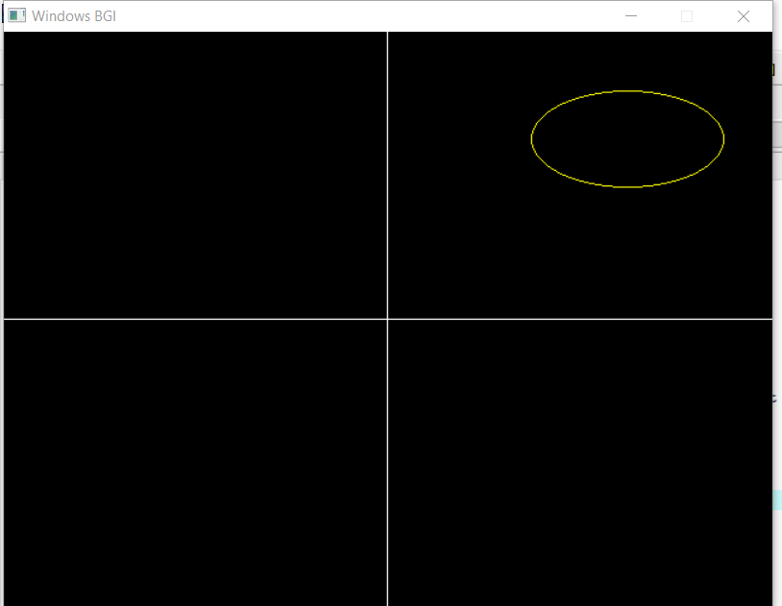

1. – **QUADRANT**

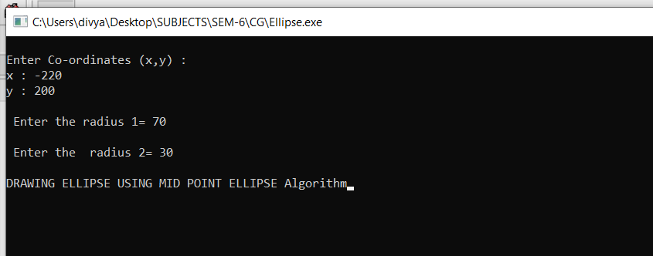

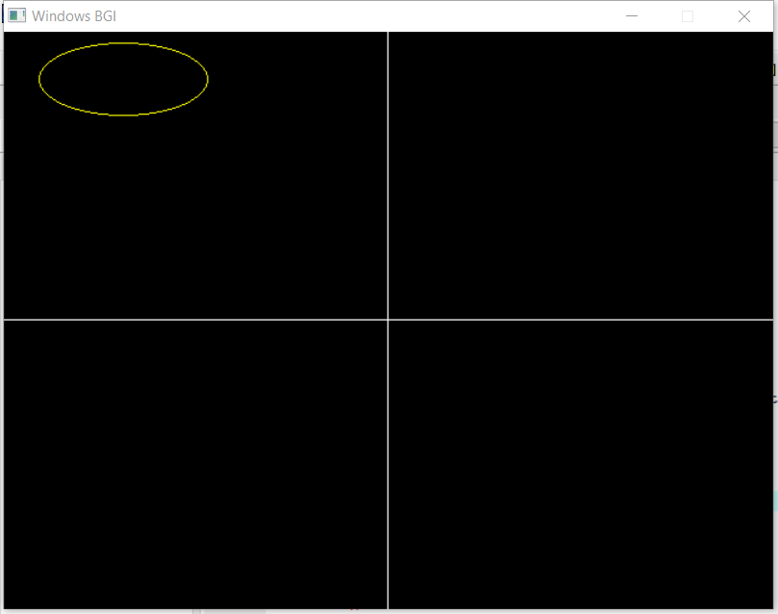

1. **- QUADRANT**

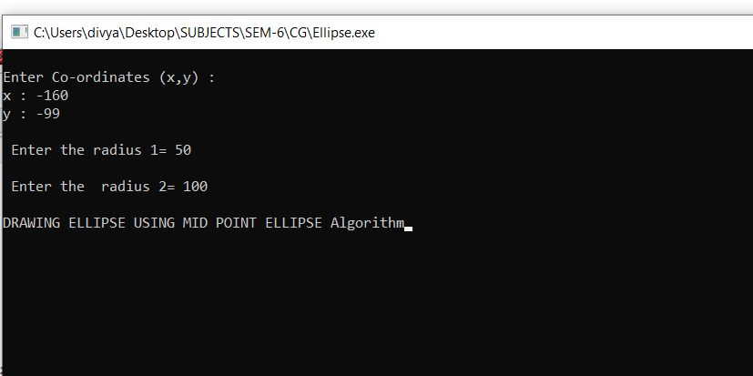

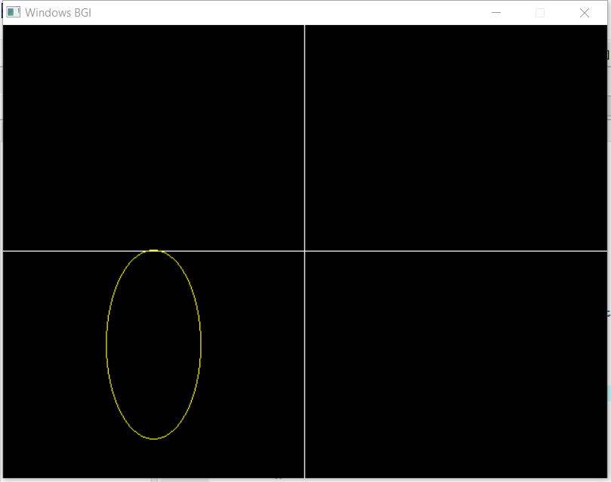

1. **– QUADRANT**

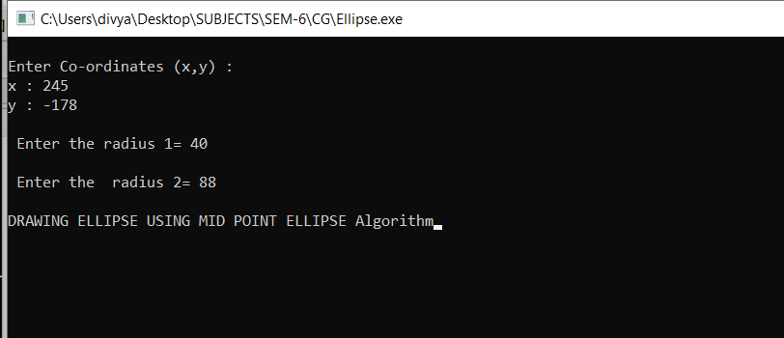

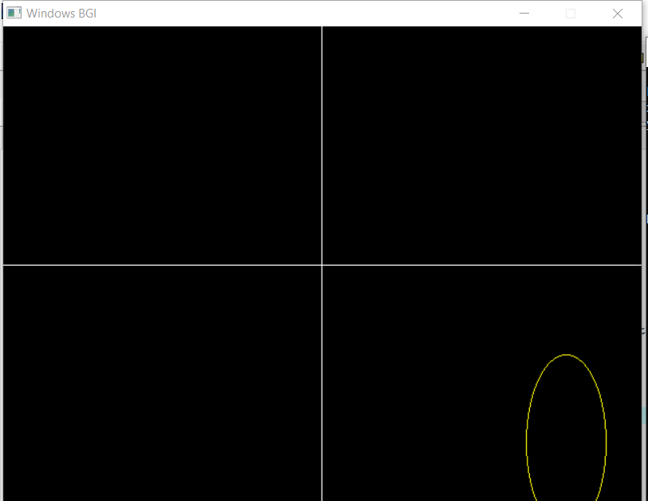

1. **Write a program to clip a line using Cohen and Sutherland line clipping algorithm**.

## CODE:

#include<iostream> #include<graphics.h> #include<conio.h> #include<math.h>

using namespace std;

#define ROUND(a) ((int)(a+0.5)) #define INSIDE(a) (!a)

#define REJECT(a, b) (a&b) #define ACCEPT(a, b) ( ! (a|b) )

/* Bit masks encode a point's position relative to the clip edges. A point's status is encoded by OR'ing together appropriate bit masks */

int LEFT_EDGE =1 ; int RIGHT_EDGE =20 ;

int BOTTOM_EDGE =4 ; int TOP_EDGE =80;

//defining struct for dcpt struct dcPt

{

int x, y;

};

//defining struct for wcpt2 struct wcPt2

{

int x,y;

};

//fuction for drawing the line

void lineDDA (int xa, int ya, int xb, int yb)

{

cout<<"DDA line called "<<endl;

//calculating dx and dy

int dx = xb - xa, dy = yb - ya, steps, k;

float xIncrement, yIncrement, x = xa, y = ya;

// difference(dx,dy) with the greater magnitude determines the value of parameter steps if (abs (dx) > abs (dy))

steps = abs (dx) ;

else

steps = abs (dy);

xIncrement = dx/(float) steps; yIncrement = dy/(float) steps;

putpixel (ROUND(x), ROUND(y),YELLOW );

//looping to generate next pixcel position step times for (k=0; k<steps; k++)

{

x += xIncrement; y += yIncrement;

putpixel (ROUND(x), ROUND(y),YELLOW );

}

cout<<"DAA line returned "<<endl;

}

unsigned char encode (wcPt2 pt, dcPt winMin, dcPt winMax)

{

unsigned char code=0; if (pt.x <winMin.x)

code = code | LEFT_EDGE; if (pt.x > winMax.x)

code = code | RIGHT_EDGE; if (pt .y < winMin. y)

code = code | BOTTOM_EDGE; if (pt .y > winMax. y)

code = code | TOP_EDGE; return (code) ;

}

void swapPts (wcPt2 * p1, wcPt2 * p2)

{

wcPt2 tmp; tmp=*p1 ;

*p1=*p2;

*p2=tmp;

}

void swapCodes (unsigned char * c1, unsigned char * c2)

{

unsigned char tmp; tmp = *c1;

*c1 = *c2;

*c2 = tmp;

}

//fuction for implementing clip line algo

void clipLine (dcPt winMin, dcPt winMax, wcPt2 p1, wcPt2 p2)

{

unsigned char code1, code2; int done = FALSE, draw = FALSE; float m; //slope of line

while (!done)

{

code1 = encode (p1, winMin, winMax); code2 = encode (p2, winMin, winMax); if (ACCEPT (code1, code2 ) )

{

done = TRUE; draw = TRUE;

}

else

{

if (REJECT (code1, code2))

{

done = TRUE;

}

else

{

if (INSIDE (code1))

{

swapPts (&p1, &p2) ; swapCodes (&code1, &code2);

}

if (p2.x != p1.x)

{

m = (p2.y - p1.y) / (p2.x - p1.x); //calculating the slope

}

if (code1 & LEFT_EDGE)

{

p1.y += (winMin.x - p1.x)*m; p1.x = winMin.x;

}

else

{

if (code1 & RIGHT_EDGE)

{

p1.y += (winMax.x - p1.x)* m; p1.x = winMax.x;

}

else

{

if (code1 & BOTTOM_EDGE)

{

if (p2.x != p1.x)

{

p1.x += (winMax.y - p1.y) / m;

}

p1.y = winMax.y;

}

else

{

if (code1 & TOP_EDGE)

{

if (p2.x != p1.x)

{

p1.x += (winMax.y - p1.y) / m;

}

p1.y = winMax.y;

}

}

}

}

}

}

}

if(draw)

{

//calling the lineDDA fuction to draw the line after the cliping lineDDA(ROUND(p1.x),ROUND(p1.y), ROUND(p2.x), ROUND(p2.y));

}

}

//main function int main()

{

int gdriver = DETECT,gmode; initgraph(&gdriver,&gmode,(char*)""); dcPt winMin,winMax;

wcPt2 p1, p2;

//values oh winMin(window min ) and winMax(window max) winMin.x = 10; winMin.y = 10;

winMax.x = 240;

winMax.y = 240;

//values of p1 and p2 p1.x = 10;

p1.y = 10;

p2.x = 180;

p2.y = 180;

cout<<"p1.x :"<<p1.x;

cout<<"\np1.y :"<<p1.y; cout<<"\np2.x :"<<p2.x; cout<<"\np2.y :"<<p2.y;

cout<<"\n*******COHEN AND SUTHERLAND LINE CLIPPING *******"<<endl;

//drawing the rectangle rectangle(winMin.x,winMin.y,winMax.x,winMax.y);

//calling clip line function

clipLine (winMin, winMax, p1, p2);

getch(); return 0;

}

**OUTPUT :**

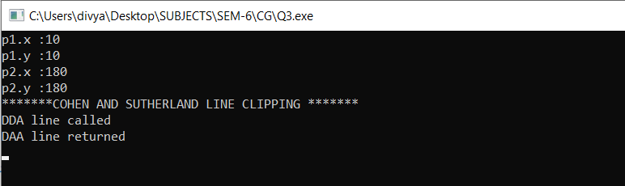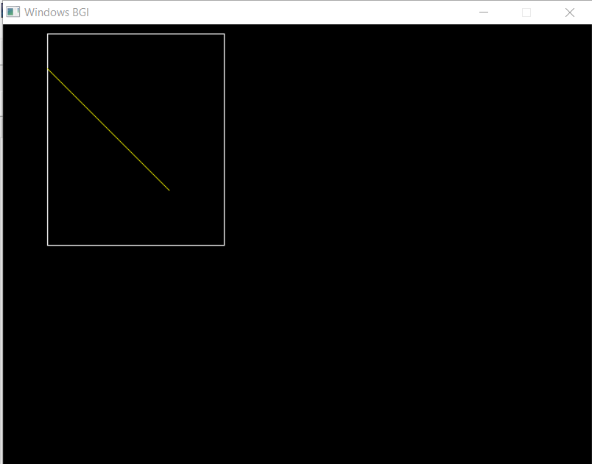

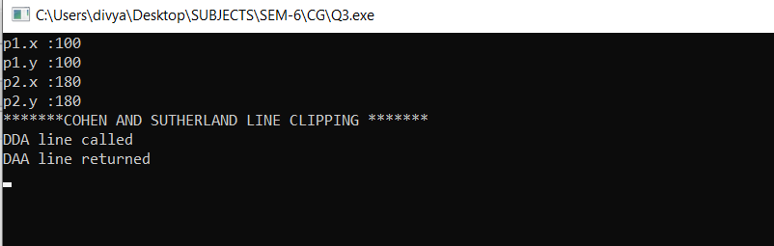

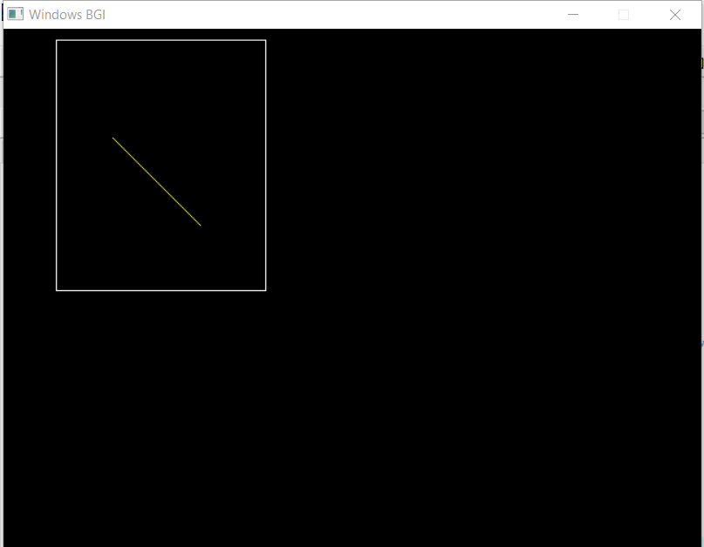

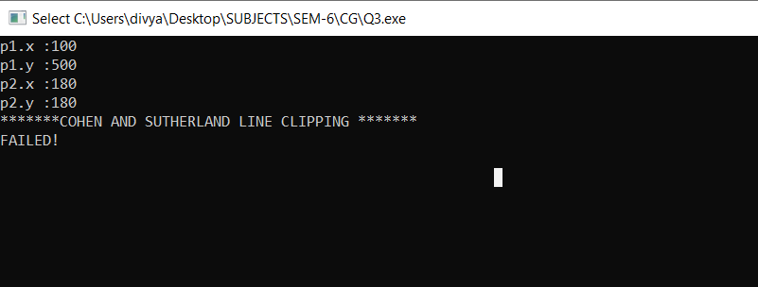

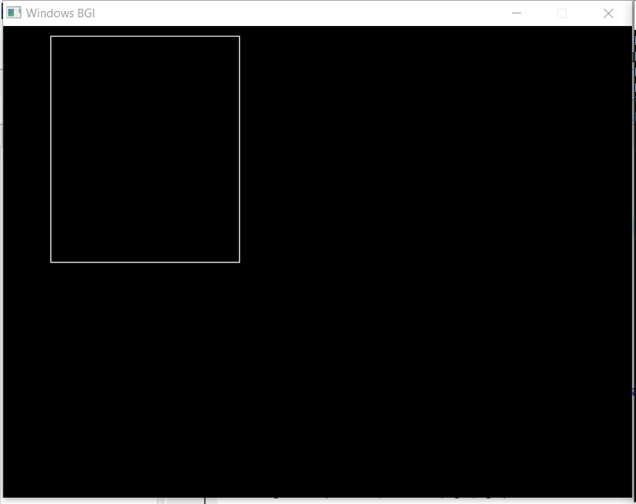

1. **Write a program to clip a polygon using Sutherland Hodgeman algorithm.**

#include<iostream> #include<conio.h> #include<graphics.h> using namespace std;

#define round(a) ((int)(a+0.5))

int k;

float xmin,ymin,xmax,ymax,arr[20],m; // Coordinates for the Rectangular Window

//Clipping Against Left Edge if the Window void clipleft(float x1,float y1,float x2,float y2)

{

//Four conditions(in->in, in->out, out->in, out->out) if(x2-x1)

m=(y2-y1)/(x2-x1); else

m=100000;

if(x1 >= xmin && x2 >= xmin)

{

arr[k]=x2; arr[k+1]=y2; k+=2;

}

if(x1 < xmin && x2 >= xmin)

{

arr[k]=xmin; arr[k+1]=y1+m*(xmin-x1); arr[k+2]=x2;

arr[k+3]=y2; k+=4;

}

if(x1 >= xmin && x2 < xmin)

{

arr[k]=xmin; arr[k+1]=y1+m*(xmin-x1); k+=2;

}

}

//Clipping Against Top Edge of The Window void cliptop(float x1,float y1,float x2,float y2)

{

if(y2-y1)

m=(x2-x1)/(y2-y1); else

m=100000;

if(y1 <= ymax && y2 <= ymax)

{

arr[k]=x2; arr[k+1]=y2; k+=2;

}

if(y1 > ymax && y2 <= ymax)

{

arr[k]=x1+m*(ymax-y1); arr[k+1]=ymax; arr[k+2]=x2; arr[k+3]=y2;

k+=4;

}

if(y1 <= ymax && y2 > ymax)

{

arr[k]=x1+m*(ymax-y1); arr[k+1]=ymax;

k+=2;

}

}

//Clipping Against Right Edge of the Window void clipright(float x1,float y1,float x2,float y2)

{

if(x2-x1)

m=(y2-y1)/(x2-x1); else

m=100000;

if(x1 <= xmax && x2 <= xmax)

{

arr[k]=x2; arr[k+1]=y2; k+=2;

}

if(x1 > xmax && x2 <= xmax)

{

arr[k]=xmax; arr[k+1]=y1+m*(xmax-x1); arr[k+2]=x2;

arr[k+3]=y2; k+=4;

}

if(x1 <= xmax && x2 > xmax)

{

arr[k]=xmax;

arr[k+1]=y1+m*(xmax-x1); k+=2;

}

}

//Clipping Against Bottom Edge of the Window void clipbottom(float x1,float y1,float x2,float y2)

{

if(y2-y1)

m=(x2-x1)/(y2-y1); else

m=100000;

if(y1 >= ymin && y2 >= ymin)

{

arr[k]=x2; arr[k+1]=y2; k+=2;

}

if(y1 < ymin && y2 >= ymin)

{

arr[k]=x1+m*(ymin-y1); arr[k+1]=ymin; arr[k+2]=x2; arr[k+3]=y2;

k+=4;

}

if(y1 >= ymin && y2 < ymin)

{

arr[k]=x1+m*(ymin-y1); arr[k+1]=ymin;

k+=2;

}

}

//Main Function int main()

{

int gd=DETECT,gm,n,poly[20]; initgraph(&gd,&gm,(char*)""); float xi,yi,xf,yf,polyy[20];

cout<<"Coordinates of rectangular clip window :\nxmin :"; cin>>xmin;

cout<<"ymin :"; cin>>ymin; cout<<"xmax :"; cin>>xmax;

cout<<"ymax :"; cin>>ymax;

cout<<"\n\nPolygon to be clipped :\nNumber of sides :"; cin>>n;

cout<<"Enter the coordinates :"; int i;

for(i=0;i < 2*n;i++)

cin>>polyy[i]; polyy[i]=polyy[0]; polyy[i+1]=polyy[1]; for(i=0;i < 2*n+2;i++)

poly[i]=round(polyy[i]);

//setting color to the box setcolor(RED); rectangle(xmin,ymax,ymax,ymin); cout<<"\t\tUNCLIPPED POLYGON";

setcolor(WHITE); fillpoly(n,poly);

getch(); cleardevice(); k=0;

for(i=0;i < 2*n;i+=2)

clipleft(polyy[i],polyy[i+1],polyy[i+2],polyy[i+3]);

n=k/2;

for(i=0;i < k;i++)

polyy[i]=arr[i]; polyy[i]=polyy[0]; polyy[i+1]=polyy[1];

k=0;

for(i=0;i < 2*n;i+=2)

cliptop(polyy[i],polyy[i+1],polyy[i+2],polyy[i+3]);

n=k/2;

for(i=0;i < k;i++)

polyy[i]=arr[i]; polyy[i]=polyy[0]; polyy[i+1]=polyy[1];

k=0;

for(i=0;i < 2*n;i+=2)

clipright(polyy[i],polyy[i+1],polyy[i+2],polyy[i+3]);

n=k/2;

for(i=0;i < k;i++)

polyy[i]=arr[i]; polyy[i]=polyy[0]; polyy[i+1]=polyy[1];

k=0;

for(i=0;i < 2*n;i+=2)

clipbottom(polyy[i],polyy[i+1],polyy[i+2],polyy[i+3]); for(i=0;i < k;i++)

poly[i]=round(arr[i]);

if(k)

fillpoly(k/2,poly); setcolor(RED); rectangle(xmin,ymax,xmax,ymin); cout<<"\tCLIPPED POLYGON";

getch(); closegraph();

}

# OUTPUT:

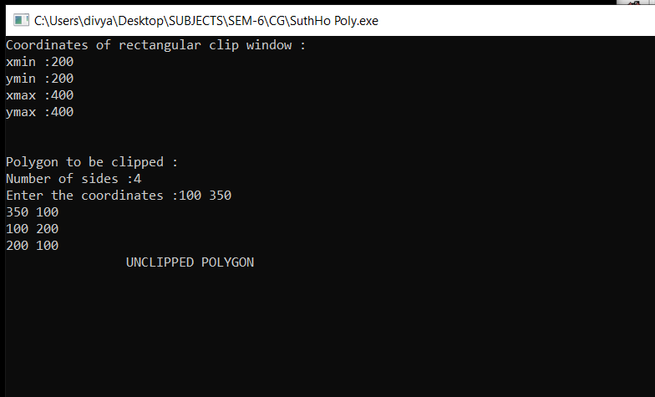

**POLYGON BEFORE CLIPPING :**

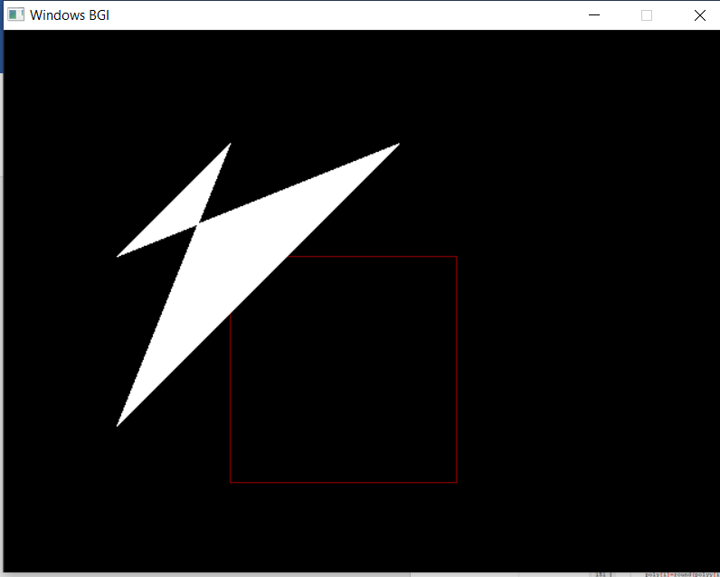

**POLYGON AFTER CLIPPING :**

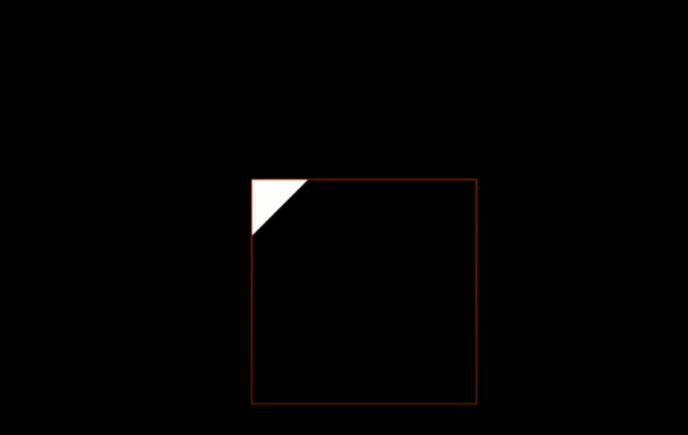

1. **Write a program to fill a polygon using Scan line fill algorithm.**

#include<iostream> #include<graphics.h> #include<math.h> using namespace std;

const int WINDOW_HEIGHT = 1000;

typedef struct tdcPt

{

}dcPt;

int x; int y;

typedef struct tEdge

{

}Edge;

int yUpper;

float xIntersect, dxPerScan; struct tEdge *next;

// Vertices: Array of structures.

dcPt vertex[5] = {{220, 340}, {210, 190}, {310, 240}, {370, 250}, {360, 320}};

// Inserts edge into list in order of increasing xIntersect field. void insertEdge(Edge *list, Edge *edge)

{

Edge *p, *q = list; p = q->next;

while (p != NULL)

{

if (edge->xIntersect < p->xIntersect) p = NULL;

else

{

}

}

q = p;

p = p->next;

edge->next = q->next; q->next = edge;

}

// For an index, return y-coordinate of next nonhorizontal line int yNext(int k, int cnt, dcPt *pts)

{

int j;

if ((k + 1) > (cnt - 1)) j = 0;

else

j = k + 1;

while(pts[k].y == pts[j].y)

{

if ((j + 1) > (cnt - 1)) j = 0;

else

}

j++;

return (pts[j].y);

}

/* Store lower-y coordinate and inverse slope for each edge. Adjust and store upper-y coordinate for edges that are the lower member of a monotically increasing or decreasing pair of edges */

void makeEdgeRec(dcPt lower, dcPt upper, int yComp, Edge *edge, Edge *edges[])

{

edge->dxPerScan = (float) (upper.x - lower.x) / (upper.y - lower.y); edge->xIntersect = lower.x;

if (upper.y < yComp)

edge->yUpper = upper.y - 1;

else

edge->yUpper = upper.y;

insertEdge(edges[lower.y], edge);

}

void buildEdgeList(int cnt, dcPt *pts, Edge *edges[])

{

Edge *edge; dcPt v1, v2;

int i, yPrev = pts[cnt - 2].y;

v1.x = pts[cnt - 1].x; v1.y = pts[cnt - 1].y; for(int i = 0; i < cnt; i++)

{

v2 = pts[i];

if (v1.y != v2.y) // non-horizontal line

{

edge = (Edge *) malloc (sizeof(Edge));

if (v1.y < v2.y) // up-going edge

makeEdgeRec(v1, v2, yNext(i, cnt, pts), edge, edges);

else // down-going edge

makeEdgeRec(v2, v1 , yPrev, edge, edges);

}

yPrev = v1.y; v1 = v2;

}

}

void buildActiveList(int scan, Edge *active, Edge *edges[])

{

Edge *p, *q;

p = edges[scan]->next; while (p)

{

q = p->next; insertEdge(active, p); p = q;

}

}

void fillScan(int scan, Edge *active)

{

Edge *p1, *p2 ; int i;

p1 = active->next; while (p1)

{

p2 = p1->next;

for(i = p1->xIntersect; i < p2->xIntersect; i++) putpixel((int) i, scan, RED);

p1 = p2->next;

}

}

void deleteAfter(Edge *q)

{

Edge *p = q->next; q->next = p->next; free(p);

}

/* Delete completed edges. Update ’xIntersect’ field for others */

void updateActiveList(int scan, Edge *active)

{

Edge *q = active, *p = active->next;

while (p)

{

if (scan >= p->yUpper)

{

}

else

{

}

}

}

p = p->next; deleteAfter(q);

p->xIntersect = p->xIntersect + p->dxPerScan; q = p;

p = p->next;

void resortActiveList(Edge *active)

{

Edge *q, *p = active->next; active->next = NULL;

while (p)

{

q = p->next; insertEdge(active, p); p = q;

}

}

void scanFill(int cnt, dcPt *pts)

{

Edge *edges[WINDOW_HEIGHT], *active; int i, scan;

for (i = 0; i < WINDOW_HEIGHT; i++)

{

edges[i] = (Edge *) malloc (sizeof(Edge));; edges[i]->next = NULL;

}

buildEdgeList(cnt, pts, edges);

active = (Edge *) malloc (sizeof(Edge));; active->next = NULL;

for (scan = 0; scan < WINDOW_HEIGHT; scan++)

{

buildActiveList(scan, active, edges);

if (active->next)

{

fillScan(scan, active); updateActiveList(scan, active) ; resortActiveList(active);

}

}

free(edges[WINDOW_HEIGHT]); free(active);

}

int main()

{

int gd = DETECT, gm; initgraph(&gd, &gm, (char*)"");

float X = getmaxx(), Y = getmaxy(); float x_mid = X / 2;

float y_mid = Y / 2;

cleardevice(); scanFill(5, vertex);

getch(); closegraph(); return 0;

}

**OUTPUT:**

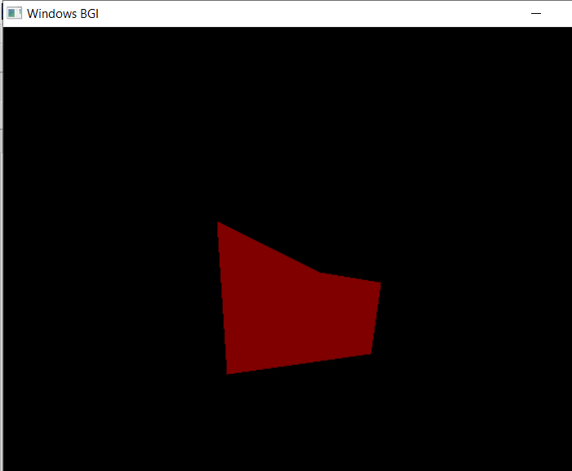

## Write a program to apply various 2-D Transformations on a 2-D object (TRIANGLE).

**CODE:**

#include<graphics.h> #include<stdlib.h> #include<stdio.h> #include<iostream> #include<conio.h> #include<math.h> using namespace std;

int mat[3][3];

//DDA line function

void dda_line(int x1 , int y1 , int x2 , int y2 , int col)

{

int dx , dy , st; dx = x2 - x1; dy = y2 - y1;

float y , x , xinc , yinc; int xmid , ymid;

xmid = getmaxx()/2; ymid = getmaxy()/2; if(abs(dx) > abs(dy))

{

st = abs(dx);

}

else

{

st = abs(dy);

}

xinc = dx / st; yinc = dy / st; x = x1;

y = y1;

for(int i=0 ; i<st ; i++)

{

x += xinc; y += yinc;

putpixel(ceil(x) + xmid , ymid - ceil(y),col);

}

}

//Rotation void rotate()

{

int xmid , ymid; xmid = getmaxx()/2; ymid = getmaxy()/2;

line(xmid , 0 , xmid , getmaxy()); line(0 , ymid , getmaxx() , ymid); int c[3][2] ,l , m, i , j , k;

int a[3][2]={{200,200},{200,100},{100,200}};

int t[2][2]={{0,1},{-1,0}};

for( i = 0 ; i < 3 ; i++)

{

for(j=0 ; j<2 ; j++)

{

c[i][j]=0;

}

}

//Original Triangle dda_line(a[0][0],a[0][1],a[1][0],a[1][1],YELLOW);

dda_line(a[1][0],a[1][1],a[2][0],a[2][1],YELLOW);

dda_line(a[2][0],a[2][1],a[0][0],a[0][1],YELLOW);

for ( i=0;i<3;i++)

{

for ( j=0;j<2;j++)

{

for ( k=0;k<2;k++)

{

c[i][j]=c[i][j]+(a[i][k]*t[k][j]);

}

}

}

//Transformed Triangle dda_line(c[0][0],c[0][1],c[1][0],c[1][1],GREEN);

dda_line(c[1][0],c[1][1],c[2][0],c[2][1],GREEN);

dda_line(c[2][0],c[2][1],c[0][0],c[0][1],GREEN);

}

//Reflection void reflection()

{

int xmid , ymid; xmid = getmaxx()/2; ymid = getmaxy()/2;

line(xmid , 0 , xmid , getmaxy()); line(0 , ymid , getmaxx() , ymid); int c[3][2] ,l , m, i , j , k;

int a[3][2]={{200,200},{200,100},{100,200}};

int t[2][2]={{0,-1},{-1,0}};

for( i = 0 ; i < 3 ; i++)

{

for(j=0 ; j<2 ; j++)

{

c[i][j]=0;

}

}

//Original Triangle

dda_line (a[0][0],a[0][1],a[1][0],a[1][1],YELLOW);

dda_line(a[1][0],a[1][1],a[2][0],a[2][1],YELLOW);

dda_line(a[2][0],a[2][1],a[0][0],a[0][1],YELLOW);

for ( i=0;i<3;i++)

{

for ( j=0;j<2;j++)

{

for ( k=0;k<2;k++)

{

c[i][j]=c[i][j]+(a[i][k]*t[k][j]);

}

}

}

//Transformed Triangle dda_line(c[0][0],c[0][1],c[1][0],c[1][1],GREEN);

dda_line(c[1][0],c[1][1],c[2][0],c[2][1],GREEN);

dda_line(c[2][0],c[2][1],c[0][0],c[0][1],GREEN);

}

//Scaling void scaling()

{

int xmid , ymid; xmid = getmaxx()/2; ymid = getmaxy()/2;

line(xmid , 0 , xmid , getmaxy()); line(0 , ymid , getmaxx() , ymid);

int c[3][2] ,l , m, i , j , k;

int a[3][2]={{20,20},{20,10},{10,20}};

int t[2][2]={{5,0},{0,5}};

for( i = 0 ; i < 3 ; i++)

{

for(j=0 ; j<2 ; j++)

{ c[i][j]=0;

}

}

//Original Triangle dda_line(a[0][0],a[0][1],a[1][0],a[1][1],YELLOW);

dda_line(a[1][0],a[1][1],a[2][0],a[2][1],YELLOW);

dda_line(a[2][0],a[2][1],a[0][0],a[0][1],YELLOW);

for ( i=0;i<3;i++)

{

for ( j=0;j<2;j++)

{

for ( k=0;k<2;k++)

{

c[i][j]=c[i][j]+(a[i][k]*t[k][j]);

}

}

}

//Transformed Triangle dda_line(c[0][0],c[0][1],c[1][0],c[1][1],GREEN);

dda_line(c[1][0],c[1][1],c[2][0],c[2][1],GREEN);

dda_line(c[2][0],c[2][1],c[0][0],c[0][1],GREEN);

}

void multi(int a[3][3] , int b[3][3] )

{

int i , j ,k; int c[3][3];

for( i = 0 ; i < 3 ; i++)

{

for(j=0 ; j< 3 ; j++)

{

c[i][j]=0;

}

}

for ( i=0;i<3;i++)

{

for ( j=0;j<3;j++)

{

for ( k=0;k<3;k++)

{

c[i][j]=c[i][j]+(a[i][k]*b[k][j]);

}

}

}

for( i = 0 ; i < 3 ; i++)

{

for(j=0 ; j< 3 ; j++)

{

mat[i][j]=c[i][j];

}

}

}

//Reflection About an arbitrary line void reflection_arbitrary()

{

int xmid , ymid; xmid = getmaxx()/2; ymid = getmaxy()/2;

line(xmid , 0 , xmid , getmaxy());

line(0 , ymid , getmaxx() , ymid);

int a[3][3]={{200,200,1},{200,100,1},{100,200,1}};

int t[3][3]={{1,0,0},{0,1,0},{0,0,1}};

int r[3][3]={{-1,0,0},{0,-1,0},{0,0,1}};

int ref[3][3]={{1,0,0},{0,-1,0},{0,0,1}};

int rinv[3][3]={{-1,0,0},{0,-1,0},{0,0,1}};

int tinv[3][3]={{1,0,0},{0,1,0},{0,1,1}};

//Original Triangle dda_line(a[0][0],a[0][1],a[1][0],a[1][1],YELLOW);

dda_line(a[1][0],a[1][1],a[2][0],a[2][1],YELLOW);

dda_line(a[2][0],a[2][1],a[0][0],a[0][1],YELLOW);

multi(t,r); multi(mat,ref); multi(mat,rinv); multi(mat,tinv); multi(a,mat);

//Transformed Triangle dda_line(mat[0][0],mat[0][1],mat[1][0],mat[1][1],GREEN);

dda_line(mat[1][0],mat[1][1],mat[2][0],mat[2][1],GREEN);

dda_line(mat[2][0],mat[2][1],mat[0][0],mat[0][1],GREEN);

}

//Rotation About an arbitrary point void rotation_arbitrary()

{

int xmid , ymid; xmid = getmaxx()/2; ymid = getmaxy()/2;

line(xmid , 0 , xmid , getmaxy()); line(0 , ymid , getmaxx() , ymid); int c[3][3] , i , j , k;

int l[1][3]={{200,200,1}};

int a[3][3]={{200,200,1},{200,100,1},{100,200,1}};

int t[3][3]={{1,0,0},{0,1,0},{-133,-133,1}};

int r[3][3]={{-1,0,0},{0,-1,0},{0,0,1}};

int tinv[3][3]={{1,0,0},{0,1,0},{133,133,1}};

//Original Triangle dda_line(a[0][0],a[0][1],a[1][0],a[1][1],YELLOW);

dda_line(a[1][0],a[1][1],a[2][0],a[2][1],YELLOW);

dda_line(a[2][0],a[2][1],a[0][0],a[0][1],YELLOW);

multi(t,r); multi(mat,tinv); for( i = 0 ; i < 3 ; i++)

{

for(j=0 ; j<3 ; j++)

{

c[i][j]=0;

}

}

for ( i=0;i<3;i++)

{

for ( j=0;j<3;j++)

{

for ( k=0;k<3;k++)

{

c[i][j]=c[i][j]+(a[i][k]*mat[k][j]);

}

}

}

//Transformed Triangle dda_line(c[0][0],c[0][1],c[1][0],c[1][1],GREEN);

dda_line(c[1][0],c[1][1],c[2][0],c[2][1],GREEN);

dda_line(c[2][0],c[2][1],c[0][0],c[0][1],GREEN);

}

//main function int main()

{

int gdriver = DETECT , gmode , errorcode; initgraph(&gdriver, &gmode, "C:\\TURBOC3\\BGI"); int n , m;

cout<<" 1.Rotation \n 2.Reflection \n 3.Scaling \n 4.Reflection about an arbitrary axis \n"; cout<<" 5.Rotation about an arbitrary point\n";

cout<<" Enter your choice : "; cin>>n;

switch(n)

{

case 1 : rotate(); break;

case 2 : reflection(); break;

case 3 : scaling();

break;

case 4 : reflection_arbitrary(); break;

case 5 : rotation_arbitrary(); break;

default : cout<<"Invalid Choice\n";

}

getch();

}

**OUTPUT:**

1. **Rotation**

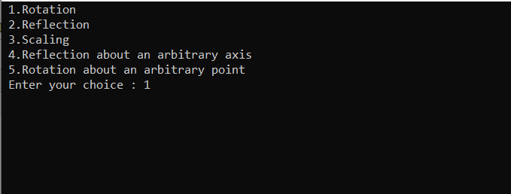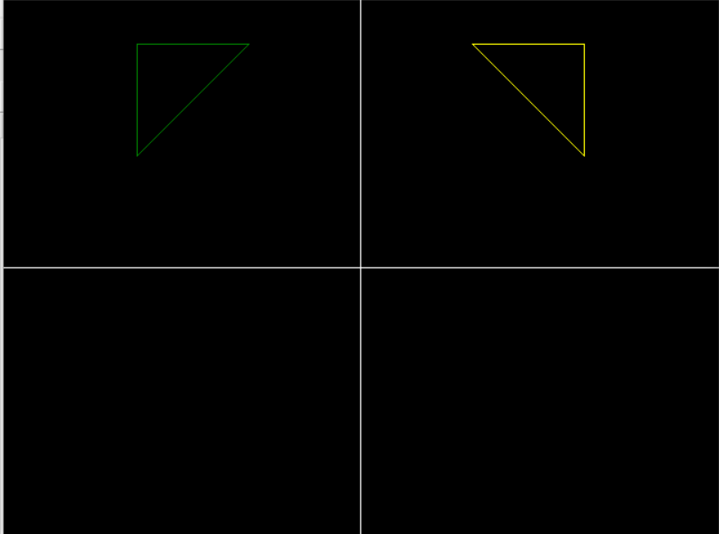

1. **Reflection**

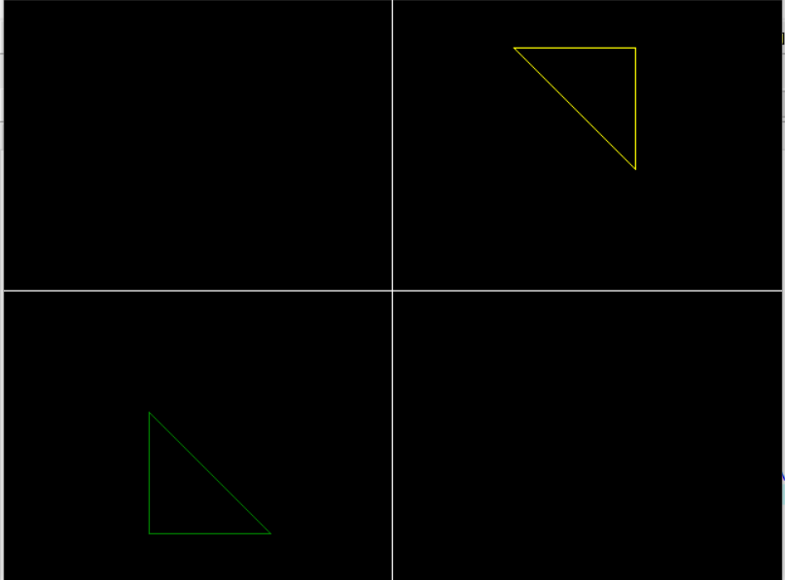

1. **Scaling**

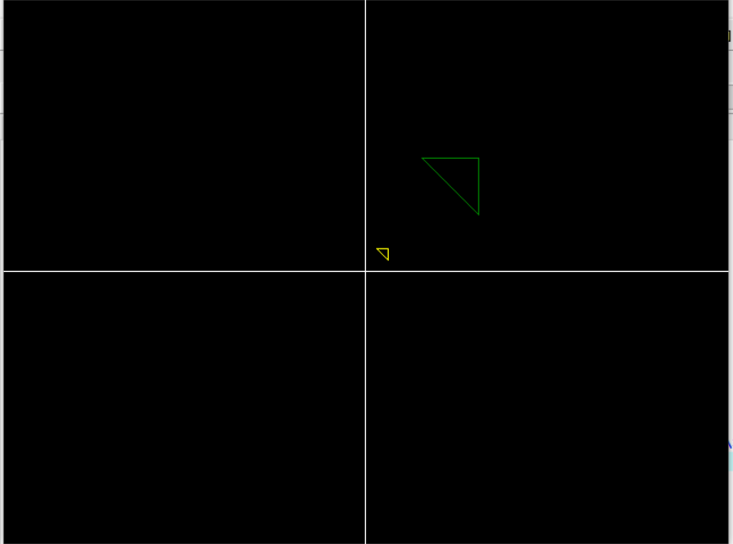

1. **Reflection about an arbitrary axis**

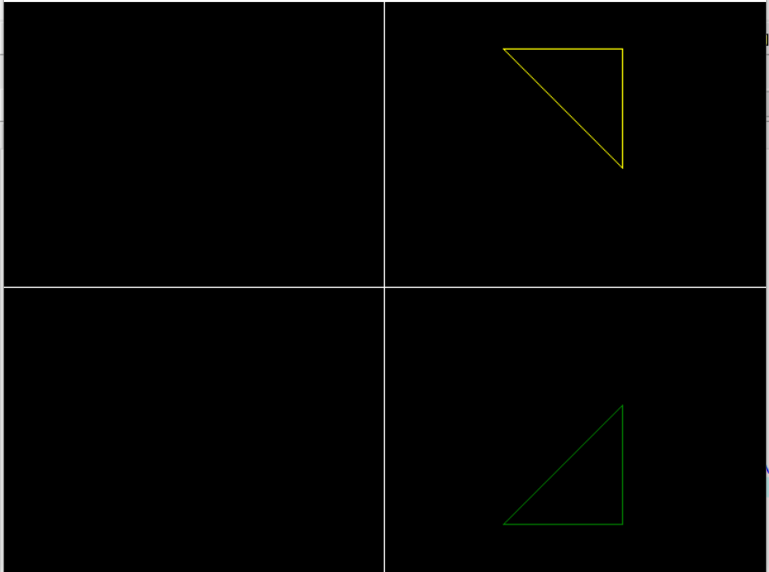

1. **Rotation about an arbitrary point**

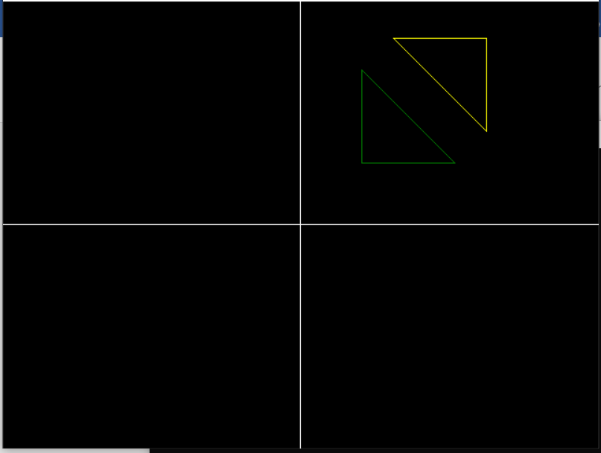

1. **Write a program to apply various 3D Transformations on a 3D object and then apply parallel and perspective projection on it.**

## CODE:

#include<iostream> #include<dos.h> #include<stdio.h> #include<math.h> #include<conio.h> #include<graphics.h> #include<process.h>

using namespace std;

int gd=DETECT,gm; double x,x2,y,y2;

//Creating draw cube function for drawing cube void draw_cube(double edge[20][3])

{

initgraph(&gd,&gm,(char*)""); int i;

clearviewport(); for(i=0;i < 19;i++)

{

x=edge[i][0]+edge[i][2]*(cos(2.3562));

y=edge[i][1]-edge[i][2]*(sin(2.3562));

x2=edge[i+1][0]+edge[i+1][2]*(cos(2.3562));

y2=edge[i+1][1]-edge[i+1][2]*(sin(2.3562)); line(x+320,240-y,x2+320,240-y2);

}

line(320,240,320,25); line(320,240,550,240); line(320,240,150,410);

getch(); closegraph();

}

//Scaling Function

void scale(double edge[20][3])

{

double a,b,c; int i;

cout<<"Enter The Scaling Factors "<<endl; cin>>a>>b>>c; initgraph(&gd,&gm,"..\bgi"); clearviewport();

for(i=0;i < 20;i++)

{ // Scaling Factors a, b, c at X, Y, Z edge[i][0]=edge[i][0]*a;

edge[i][1]=edge[i][1]*b;

edge[i][2]=edge[i][2]*c;

}

draw_cube(edge); closegraph();

}

// Creating Translation function void translate(double edge[20][3])

{

int a,b,c; int i;

cout<<"Enter The Translation Factors"<<endl; cin>>a>>b>>c;

initgraph(&gd,&gm,"..\bgi"); clearviewport();

for(i=0;i < 20;i++)

{

//Three Translation Factors a, b, c edge[i][0]+=a;

edge[i][0]+=b;

edge[i][0]+=c;

}

draw_cube(edge); closegraph();

}

// Creating Rotation About an Axes function void rotate(double edge[20][3])

{

int ch; int i;

double temp,theta,temp1;

cout<<"Rotation About"<<endl; cout<<"1 X-Axis "<<endl; cout<<"2 Y-Axis"<<endl; cout<<"3 Z-Axis "<<endl;

cout<<"Enter Your Choice "<<endl; cin>>ch;

switch(ch)

{ //For X-axis case 1:

cout<<" Enter The Angle "; cin>>theta;

theta=(theta*3.14)/180; for(i=0;i < 20;i++)

{

edge[i][0]=edge[i][0]; temp=edge[i][1]; temp1=edge[i][2];

//Transformation Matrix For X-axis edge[i][1]=temp*cos(theta)-temp1*sin(theta); edge[i][2]=temp*sin(theta)+temp1*cos(theta);

}

draw_cube(edge); break;

//For Y-axis case 2:

cout<<" Enter The Angle "; cin>>theta; theta=(theta*3.14)/180; for(i=0;i < 20;i++)

{

edge[i][1]=edge[i][1]; temp=edge[i][0]; temp1=edge[i][2];

//Transformation Matrix For Y-axis edge[i][0]=temp*cos(theta)+temp1*sin(theta); edge[i][2]=-temp*sin(theta)+temp1*cos(theta);

}

draw_cube(edge); break;

//For Z-axis case 3:

cout<<" Enter The Angle "; cin>>theta; theta=(theta*3.14)/180; for(i=0;i < 20;i++)

{

edge[i][2]=edge[i][2]; temp=edge[i][0]; temp1=edge[i][1];

//Transformation Matrix For Z-axis edge[i][0]=temp*cos(theta)-temp1*sin(theta); edge[i][1]=temp*sin(theta)+temp1*cos(theta);

}

draw_cube(edge); break;

}

}

// Creating Reflection About an Axes function void reflect(double edge[20][3])

{

int ch; int i;

cout<<"Reflection About "<<endl; cout<<"1 X-Axis"<<endl; cout<<"2 Y-Axis "<<endl; cout<<"3 Z-Axis "<<endl;

cout<<"Enter Your Choice "<<endl; cin>>ch;

switch(ch)

{ //For X-axis case 1:

for(i=0;i < 20;i++)

{

edge[i][0]=edge[i][0];

edge[i][1]=-edge[i][1];

edge[i][2]=-edge[i][2];

}

draw_cube(edge); break;

//For Y-axis case 2:

for(i=0;i < 20;i++)

{

edge[i][1]=edge[i][1];

edge[i][0]=-edge[i][0];

edge[i][2]=-edge[i][2];

}

draw_cube(edge); break;

//For Z-axis case 3:

for(i=0;i < 20;i++)

{

edge[i][2]=edge[i][2];

edge[i][0]=-edge[i][0];

edge[i][1]=-edge[i][1];

}

draw_cube(edge); break;

}

}

// Creating Perspective Projection About an Axes function void perspect(double edge[20][3])

{

int ch; int i;

double p,q,r;

cout<<"Perspective Projection About"<<endl; cout<<"1 X-Axis "<<endl;

cout<<"2 Y-Axis "<<endl; cout<<"3 Z-Axis"<<endl;

cout<<"Enter Your Choice :"<<endl; cin>>ch;

switch(ch)

{

//For X-axis case 1:

cout<<" Enter P :"; cin>>p;

for(i=0;i < 20;i++)

{

edge[i][0]=edge[i][0]/(p*edge[i][0]+1);

edge[i][1]=edge[i][1]/(p*edge[i][0]+1);

edge[i][2]=edge[i][2]/(p*edge[i][0]+1);

}

draw_cube(edge); break;

//For Y-axis

case 2: cout<<" Enter Q :"; cin>>q;

for(i=0;i < 20;i++)

{

edge[i][1]=edge[i][1]/(edge[i][1]*q+1);

edge[i][0]=edge[i][0]/(edge[i][1]*q+1);

edge[i][2]=edge[i][2]/(edge[i][1]*q+1);

}

draw_cube(edge); break;

//For Z-axis case 3:

cout<<" Enter R :"; cin>>r;

for(i=0;i < 20;i++)

{

edge[i][2]=edge[i][2]/(edge[i][2]*r+1);

edge[i][0]=edge[i][0]/(edge[i][2]*r+1);

edge[i][1]=edge[i][1]/(edge[i][2]*r+1);

}

draw_cube(edge); break;

}

closegraph();

}

//Main Function int main()

{

int choice;

double edge[20][3]={

100,0,0,

100,100,0,

0,100,0,

0,100,100,

0,0,100,

0,0,0,

100,0,0,

100,0,100,

100,75,100,

75,100,100,

100,100,75,

100,100,0,

100,100,75,

100,75,100,

75,100,100,

0,100,100,

0,100,0,

0,0,0,

0,0,100,

100,0,100

};

while(1)

{

cout<<"1 Draw Cube "<<endl; cout<<"2 Scaling "<<endl; cout<<"3 Rotation "<<endl; cout<<"4 Reflection "<<endl; cout<<"5 Translation "<<endl;

cout<<"6 Perspective Projection "<<endl; cout<<"7 Exit "<<endl;

cout<<"\nEnter Your Choice :"; cin>>choice;

switch(choice)

{

case 1:

draw_cube(edge); break;

case 2:

scale(edge); break;

case 3:

rotate(edge); break;

case 4:

reflect(edge); break;

case 5:

translate(edge); break;

case 6:

perspect(edge); break;

case 7:

exit(0);

default:

cout<<" Press A Valid Key...!!! "; getch();

break;

}

closegraph();

}

return 0;

}

**OUTPUT:**

## ORIGINAL CUBE:

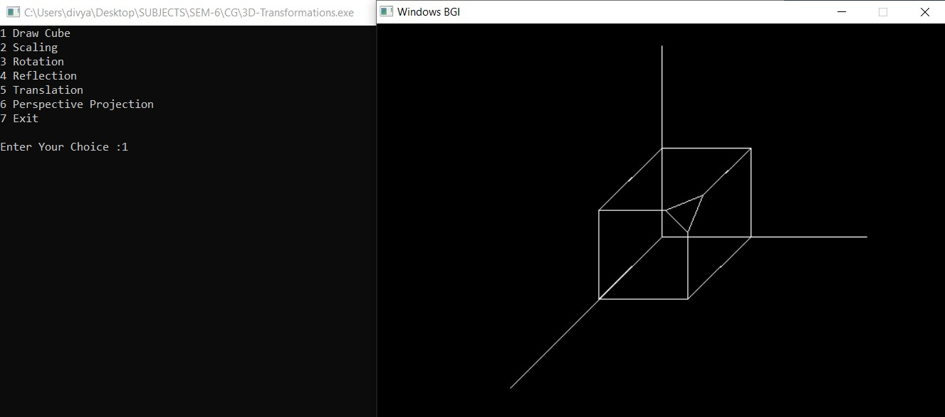

**SCALING OF CUBE WITH FACTOR 2 UNIT :**

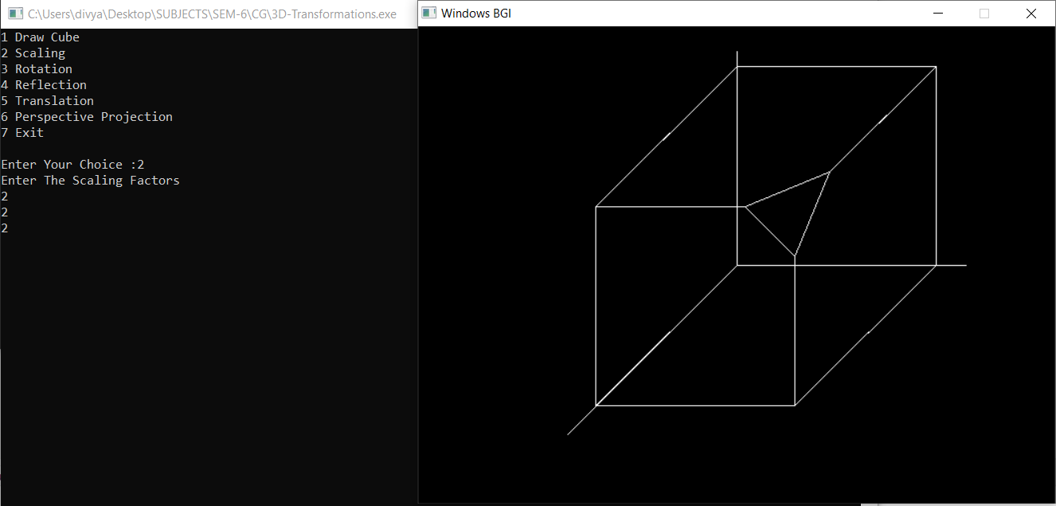

**ROTATION OF A CUBE ABOUT X-AXIS WITH ANGLE 30 DEGREE**

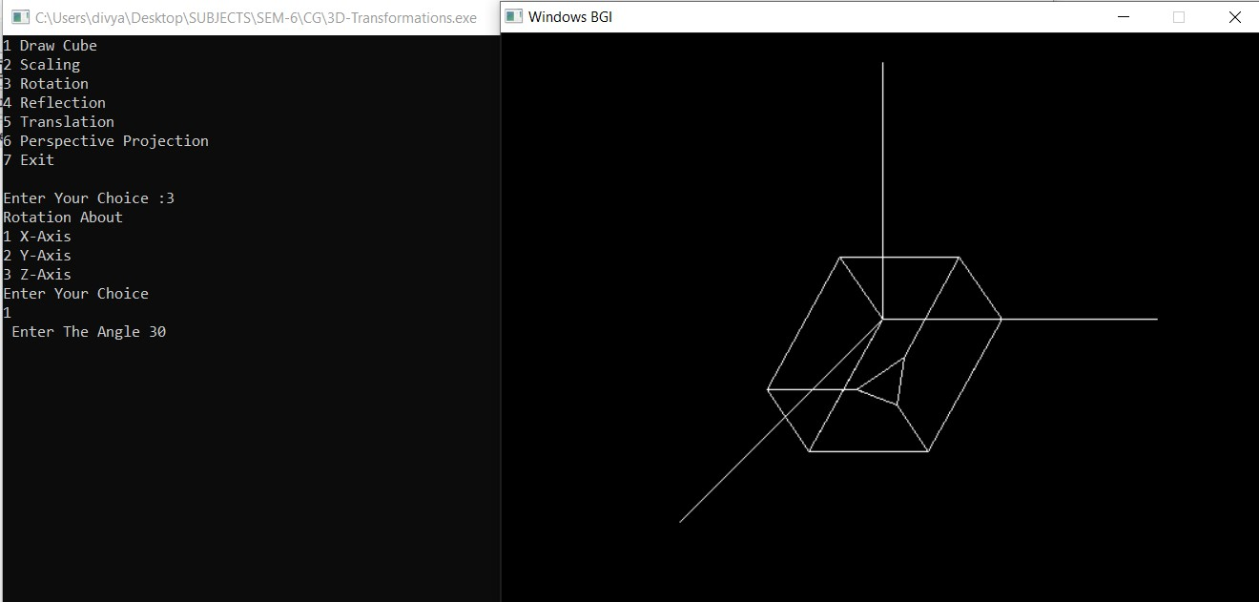

**ROTATION OF A CUBE ABOUT Y-AXIS WITH ANGLE 60 DEGREE**

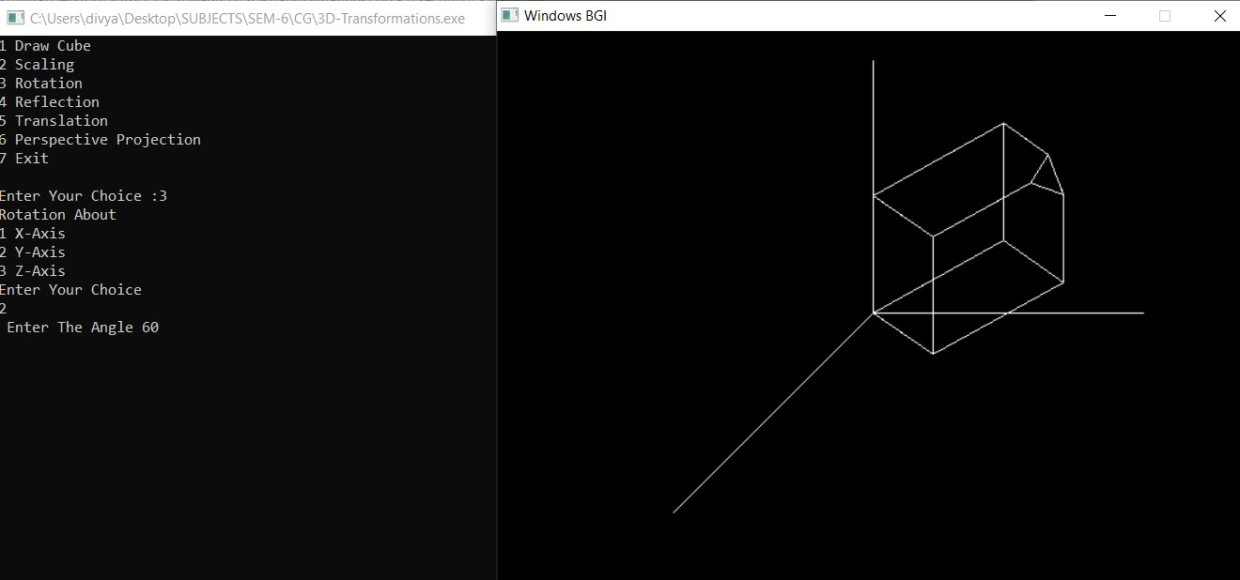

**REFLECTION OF A CUBE ABOUT Z-AXIS**

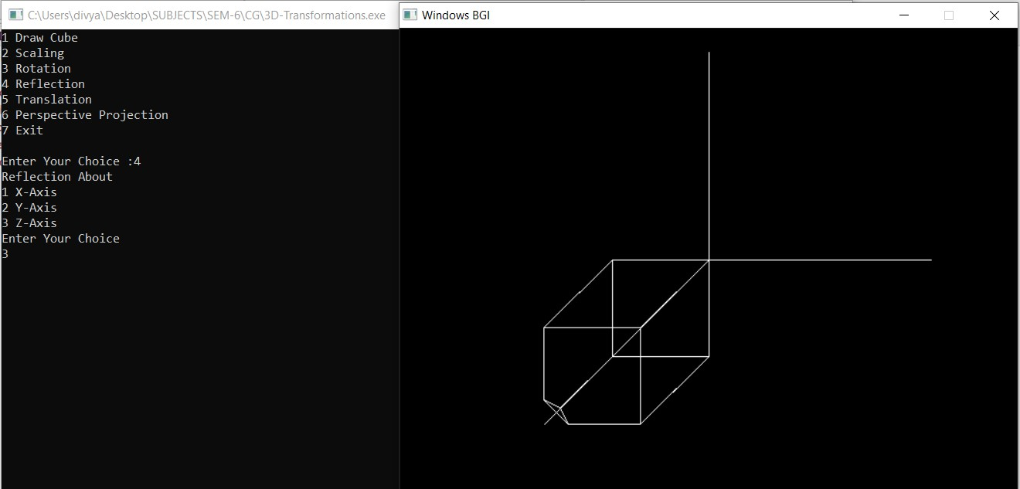

**TRANSLATION OF A CUBE WITH FACTORS (30, 40, 60)**

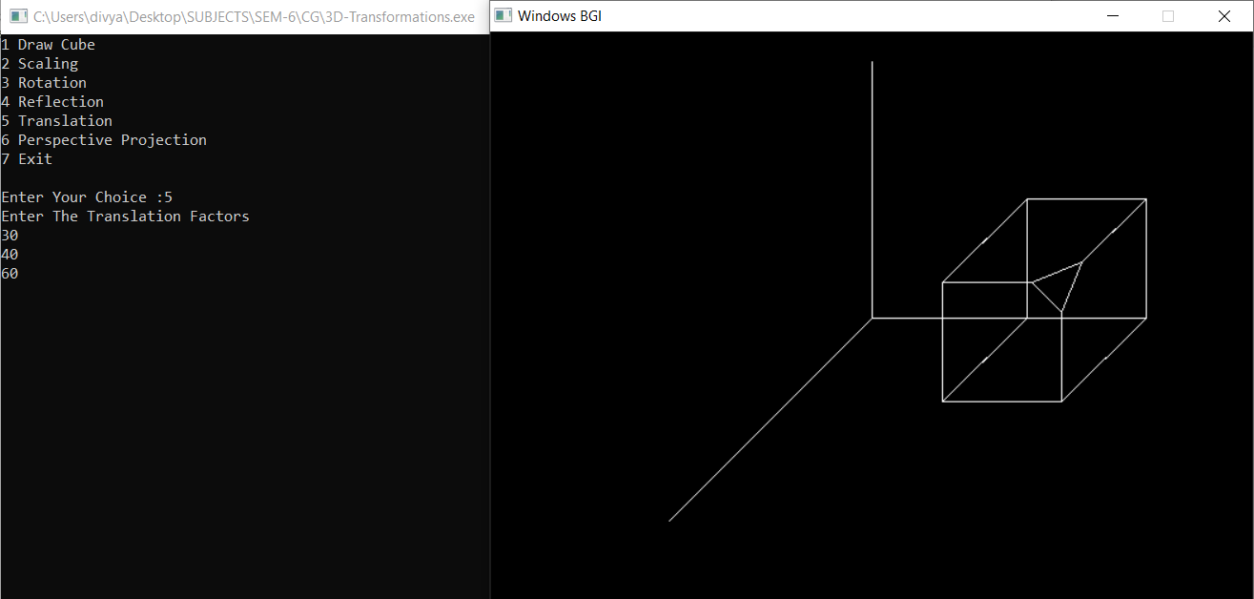

**PERSPECTIVE PROJECTION ABOUT X-AXIS WITH P=-4**

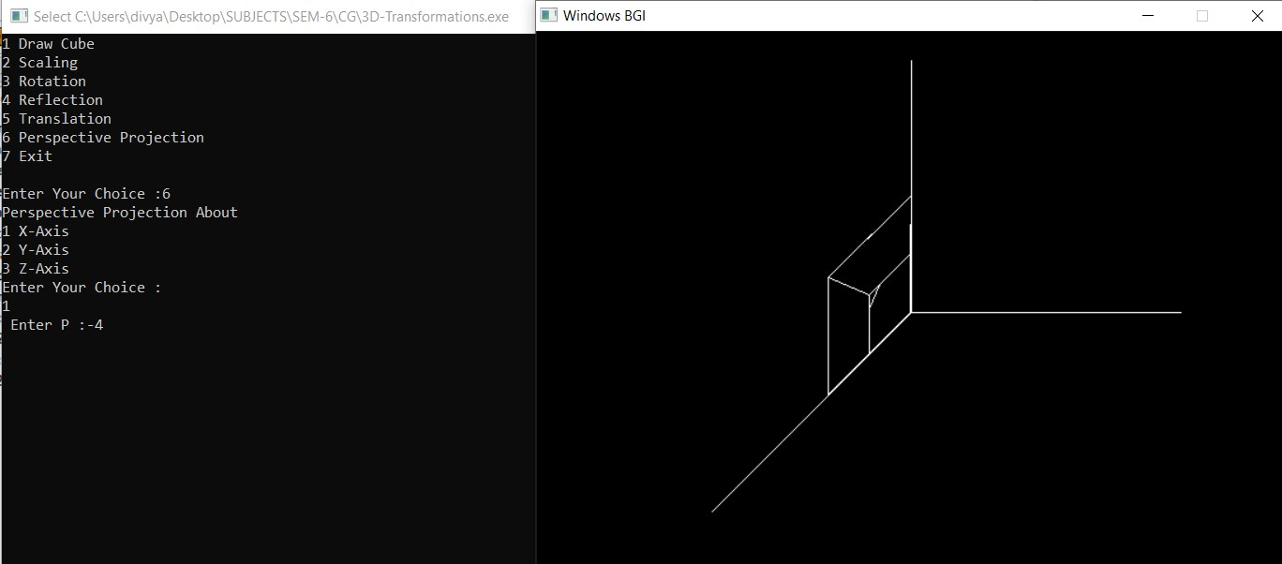

1. **Write a program to draw Hermite and Bezier curve.**

**CODE:**

#include<iostream> #include<graphics.h> #include<math.h>

using namespace std;

//creating Bezier curve function void bezier_curve(int x[4], int y[4])

{

double t;

for(t=0.0;t<1.0;t=t+0.0005)

{

//Curve Equation of x and y coordinates by using blending function

double xt=pow(1-t,3)*x[0]+3*t*pow(1- t,2)*x[1]+3*pow(t,2)*(1-t)*x[2]+pow(t,3)*x[3];

double yt=pow(1-t,3)*y[0]+3*t*pow(1- t,2)*y[1]+3*pow(t,2)*(1-t)*y[2]+pow(t,3)*y[3]; putpixel(xt,yt,YELLOW);

}

for(int i=0;i<3;i++)

{

line(x[i],y[i],x[i+1],y[i+1]);

}

}

//creating Hermite curve function

void hermite_curve(int x1,int y1,int x2,int y2,double t1,double t4)

{

float x,y,t; for(t=0.0;t<=1.0;t+=0.001)

{

//x and y equation

x=(2*t*t*t-3*t*t+1)*x1+(-2*t*t*t+3*t*t)*x2+(t*t*t- 2*t*t+t)*t1+(t*t*t-t*t)*t4; y=(2*t*t*t-3*t*t+1)*y1+(-2*t*t*t+3*t*t)*y2+(t*t*t- 2*t*t+1)*t1+(t*t*t-t*t)*t4; putpixel(x,y,YELLOW);

}

putpixel(x1,y1,GREEN); putpixel(x2,y2,GREEN); line(x1,y1,x2,y2);

}

//main function int main()

{

int gd = DETECT , gm; initgraph(&gd, &gm, (char*)"");

int x1 , y1 , x2 , y2 , n; double t1,t4;

int x[4],y[4],i;

cout<<" 1.Bezier Curve \n 2.Hermite Curve\n"; cout<<"\n Enter your choice : ";

cin>>n; if(n==1)

{

//input coordinates of x and y for Bezier curve cout<<"Enter x and y coordinates \n"; for(i=0;i<4;i++)

{

cout<<"x"<<i+1<<" : "; cin>>x[i]; cout<<"y"<<i+1<<" : "; cin>>y[i];

cout<<endl;

}

//calling Bezier curve function bezier_curve(x,y);

}

else if(n==2)

{ //input coordinates for hermite curve

cout<<"Enter the x coordinate of 1st hermite point : "; cin>>x1;

cout<<"Enter the y coordinate of 1st hermite point : "; cin>>y1;

cout<<"Enter the x coordinate of 4th hermite point : "; cin>>x2;

cout<<"Enter the y coordinate of 4th hermite point : "; cin>>y2;

cout<<"Enter tangent at p1 : "; cin>>t1;

cout<<"Enter tangent at p4 : "; cin>>t4;

//calling hermite curve function hermite_curve(x1,y1,x2,y2,t1,t4);

}

else

{

cout<<"\n Invalid Choice";

}

getch();

return 0;

}

## OUTPUT:

**BEZIER CURVE :**

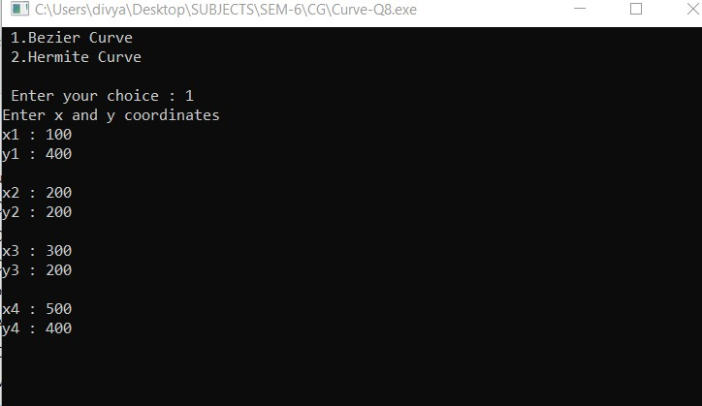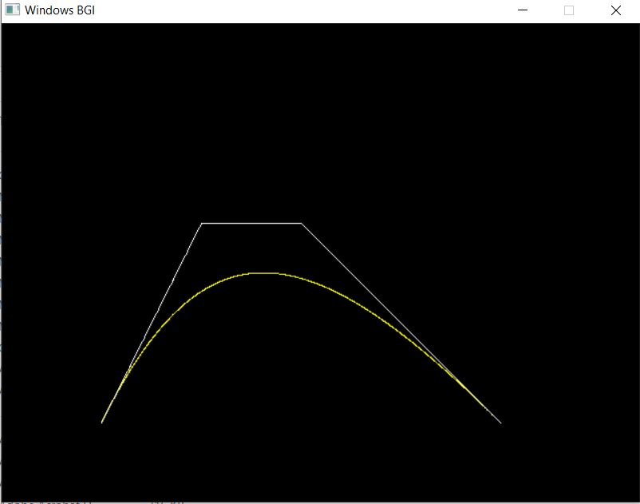

**HERMITE CURVE :**

